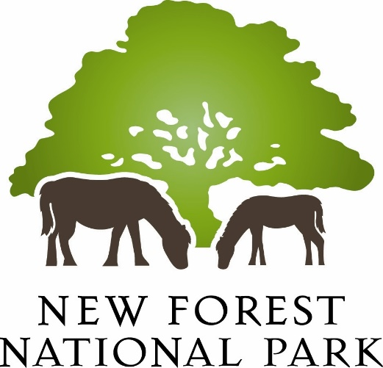

Micro-forest photography competition entry form

Name:
I confirm I am over 18 years of age (please place a cross here) [ ]
Email address:
Phone number:
Title of photograph:
Species (if known):
Approximate size of species:
Don’t miss out! Please place a cross here if you would like to receive our monthly New Forest National Park email newsletters [ ]

(You may withdraw consent at any time by clicking the unsubscribe link in the newsletter)

By entering this competition, you accept the terms and conditions of entry as seen on the website
Please email your completed form, together with your entry, to microcomp@newforestnpa.gov.uk, to arrive no later than midnight on Sunday 17 November.
How we’ll use your information
The personal information you have supplied will be used to administer the micro-forest photography competition and will be held securely. It will not be used for any purposes other than as set out above, nor will it be supplied to anyone outside the New Forest National Park Authority, unless we are obliged or permitted by law to disclose it.
We will retain your personal information for a period of three months after the closing date of the competition, after which time it will be deleted, with the exception of the names of those that have been selected for our online gallery, which will be retained for credit purposes.
The legal basis for our use of this information under the GDPR is either (a) consent and / or (f) that processing is necessary for the purposes of the legitimate interests pursued by the New Forest National Park Authority. More information can be found at: http://www.newforestnpa.gov.uk/privacyandcookies. For further information about how your information will be processed and / or if would like to access any information we hold about you, please contact our Information & Data Protection Officer on dpo@newforestnpa.gov.uk.

