Ogdens – Update October 2020

In the week beginning 9 November, work is due to start on verge restoration at Ogdens car park.

New dragon’s teeth (small chestnut posts) will be installed along the damaged roadside verge, and old posts removed which had been positioned too far off the edge of the road.

Restoration will stretch from opposite the farm along the whole length of the road, removing residents’ own measures and replacing with dragon’s teeth.

The works are necessary to prevent any further erosion to the SSSI (Site of Special Scientific Interest) and allow the Forest to recover back to its natural condition.

Temporary signage is installed on site to inform the public. Ogdens car park will already be closed between 2 November 2020 and 26 March 2021 as part of Forestry England’s winter closure programme until March 2021.

Alternative car parking is available at Abbot’s Well car park and Hyde and Gorley Commons.

Thank you for your understanding while works are carried out. Any questions? Please email hls.enquiries@forestryengland.uk

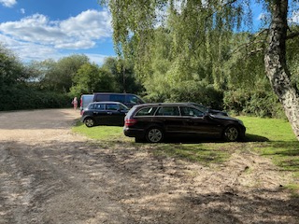

Ogdens before restoration
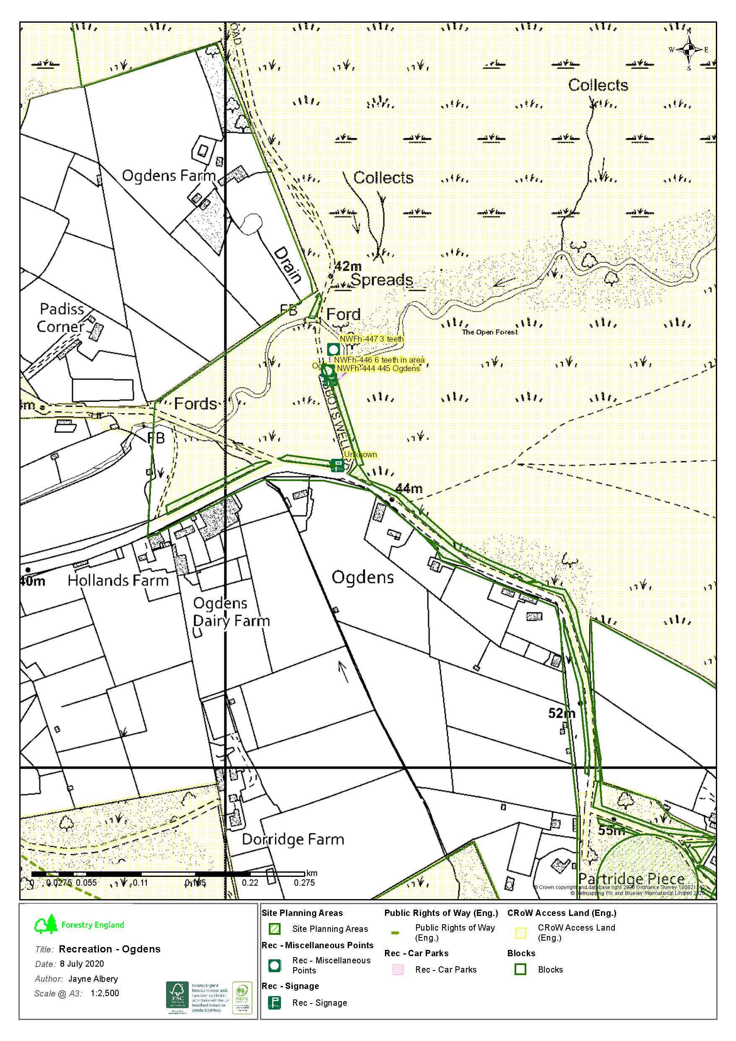
Map of works at Ogdens

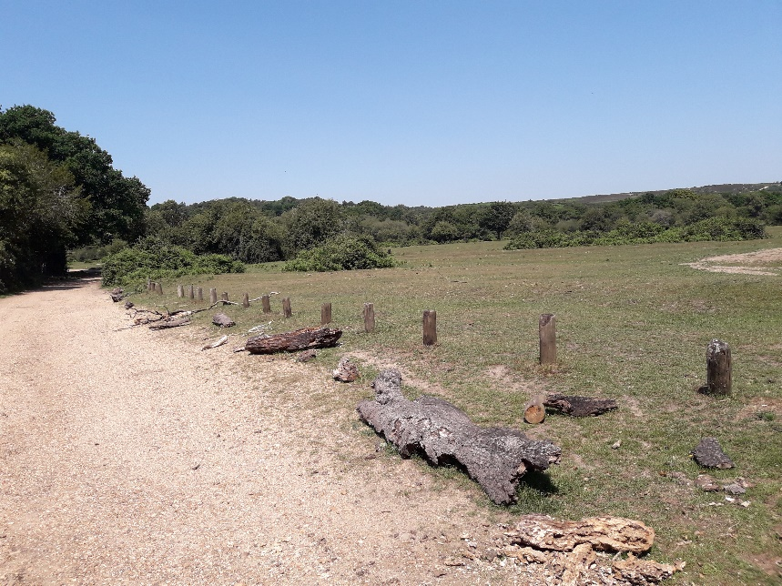

Ogdens before restoration

